4930 Code Review

# isSorted method test results

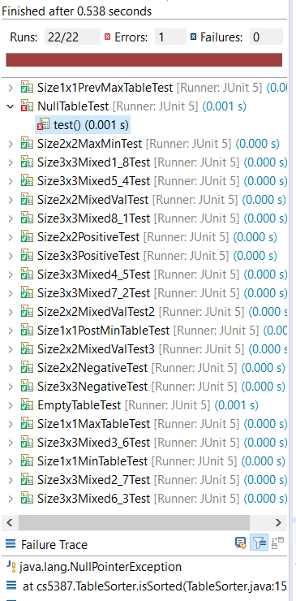We ran 22 tests on this method and all passed except for a test where a null Table reference is passed as a parameter. The code did produce the expected result of throwing a NullPointerException; however, the method lacks a “Throws” statement. This allows the programmer calling the method to ignore wrapping the call in a try-catch statement. Other than that, the code did what it was supposed to do.

# sortable() method test results

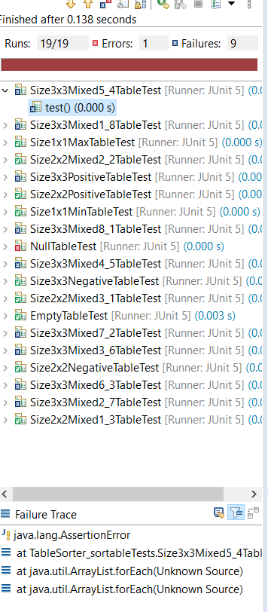We ran 19 tests on this method, but the code was only able to pass 9 of them. 1 of the problems was the same issue with the null Table described for the isSorted method previously.

In this case the code was not able to properly sort 3x3 matrices, so we can expect that the code will fail to properly sort any matrix bigger than 2x2. This means that there is a problem with the sorting algorithm, so the sort results are not reliable.